Make a Good Mega Man Level 3  
CUSTOM COSTUMES GUIDE

It’s as good as it sounds; limitless costume potential! If Maker Man’s stylish costume repertoire still isn’t enough for you, this document will explain how you can import your own costumes and enjoy the hundreds of simulations as whomever and whatever your heart desires. And for the craftier, artsier sort, a guide will be included on how to *create* your own custom costume.

Make your ideal character just the way you want them, or share your creations online and make someone else’s day. The Make a Good Mega Man Level Wiki hosts an ever-updating catalog of Custom Costumes for you to download, and the Official Discord has like-minded creators sharing their tips and progress all the time.

For veterans who already have experience making and using Custom Costumes, you’ll be blown away by the improvements: advanced buster sprite customization*, full sound effect substitution*, and most importantly**: A brand new auto-whitemask system**, allowing you to skip the most tedious part of costume-making and get right into it!

And for newcomers, I hope you find a fresh spark of inspiration.

This guide is split into two segments: Loading costumes, and creating costumes.

Loading Costumes

1. First, head to Maker Man’s Costume Shop, located on the second floor of Victor Heights, just to the left of the elevator door.

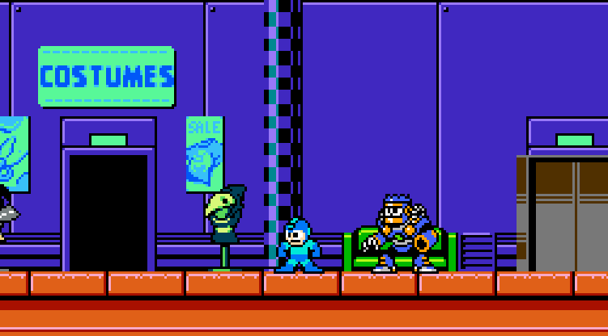

1. Talk to Maker Man and head to the last page of his Costume Gallery. From the moment the store’s open, you’ll be able to buy the Custom Costumes kit for just 200 Bolts!

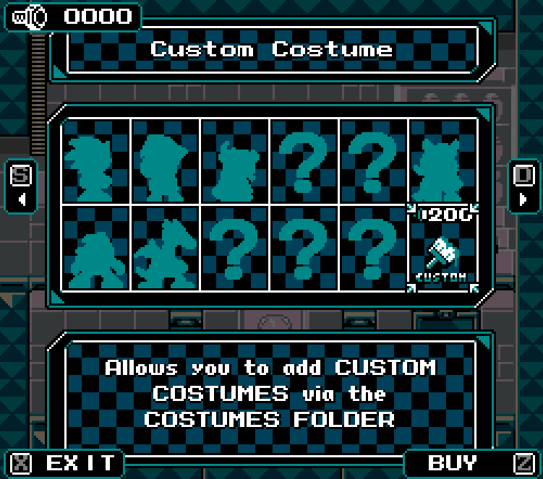

1. You’ll immediately unlock a new page of the costume catalogue, and gain *three* costumes for free**: Cirno**, **Wily Wars Mega Man**, and **Mega Man 11 Roll**. You may use these as examples for making your own costumes, or just enjoy playing as the strongest.
2. As the custom costume description said, all you have to do is download costumes off the internet/make your own and put them in the costumes folder inside the download folder. (You should already be here, if you’re reading this…) Though you can just leave costumes laying around, it’s customary to place them inside their own folders, especially since some may have custom sound effects (such as Wily Wars Mega Man for example!).

For acquiring the costumes, as stated, you may download them manually and place them in the costumes folder…. or **you may download Custom Costumes from a URL link straight to the game!** To do so, copy the URL to your clipboard. When in the Costume Shop menu, a sound should then play, followed by the MIGRATE button being replaced with a DOWNLOAD button, accessible via the slide key.

* URLs must contain “.png” or “.zip” within their URL. ZIP files will be extracted once downloaded.
* As an aside, files hosted within a Discord server nowadays have a 24-hour limit to URLs outside the application. As such, you should post your costume to a different file-hosting service, if you plan to share them outside Discord.

And if that wasn’t enough, as implied by the “MIGRATE” button, **you can now even import custom costumes from all previous MaGMMLs which supported them!** To do so, press your SPECIAL button while in the Costume selection menu, then select the PNG file. This will “transform” the costume into a MaGMML3 costume (so **keep a copy of the original!**).

Keep in mind that there may be many sprites which are “missing” in the import (a costume from MaGMML1 Remastered won’t really have Break Dash frames, for example) and will default just to Mega Man, among other quirks that you might have to fill in—This tool is more for providing a “starting point” for costume-makers than recommended for standard play.

… And that’s basically it! Get 200 Bolts, purchase the kit and then get costumes! The main repository for costumes online is the Make a Good Mega Man Level wiki, though some may use discord download links bound to expire.

So, that’s loading ‘em… But what about making ‘em?

If you join the official MaGMML discord, you can always catch people working on custom costumes in the dedicated channel. Do you wish to join in? Be just like them and make your desires reality?

Prepare for the entire rest of the document, costume-maker. This instruction guide is for you. You’ll learn to create personas, not just for yourself, but for people all over the world to wear and embody.

Robot Masters not included in the game? Crossovers with your favorite anime? Your own original characters? You can be anything, and anything can be yourself.

So make yourself and be yourself the best you can be!

Welcome to the crash course, costume-makers. I’m your host, Crafts Man. I met Maker Man back in ’08 at a baking seminar. This is…

Crafting Costumes

Making Custom Costumes is pretty intuitive. A bit of an effort, but if you follow the instructions, once you do it a few times it should become second nature. If you look in the costumes folder, you’ll find a template to follow, in the form of a grid with all the different animation frames used in-game. **Whatever the .png is named will be the name of the costume**, so start by duplicating the file and saving it under the name you want.

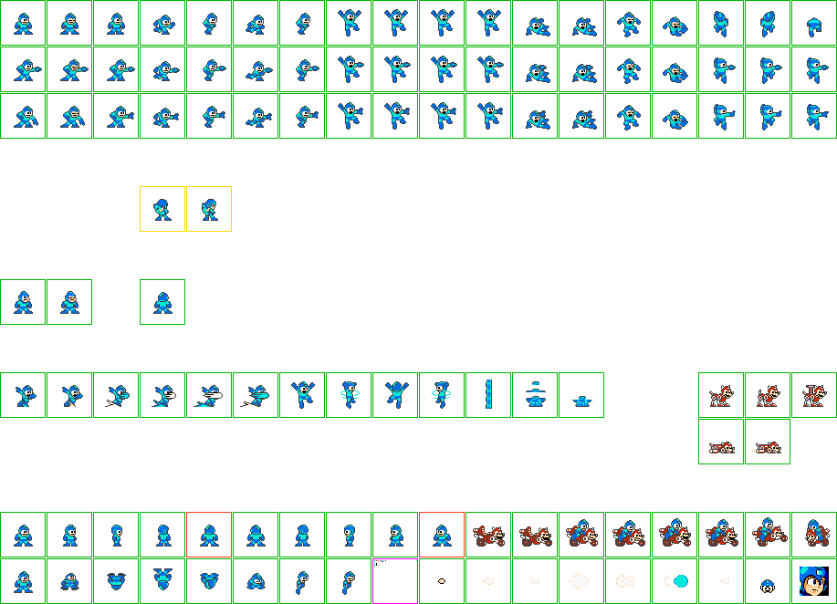

Just as you’d guess, the first thing you have to do is simply replace the sprites with the ones of your character in the respective frames. When you look at all of the frames like this, it probably looks a tad overwhelming, so take the following notes into account:

* Custom Costumes, just like normal Costumes, **have no hitbox differences**. If you make one bigger than Mega Man, try to keep in mind where the hitbox would be centered, and if you make one smaller, keep in mind you’ll be a bigger target than you first appear.
* As you may have noticed, there’s four midair frames right next to each other for normal, shooting, and throwing. The first two frames are used when going up, and the last two are used while going down. However, Mega Man himself and many costumes in the game utilize a single midair frame the whole time, so you can just copy paste them if you so wish. Additionally, costumes like Proto Man utilize the same animation going both up and down for the flowing of his scarf.
* The two slide frames are also for cases like Proto Man, where you want an animation occurring during it. You can also just keep them the same, like Mega Man.
  + (Since we’re talking about Proto Man a lot, this isn’t really a note, so much as it is a tip, but Proto Man utilizes the blinking frames to animate his scarf while idle. If your costume lacks eyes or wants a different kind of idle animation, feel free to get creative like this!)
* Shooting while sliding is **only** used as a transition frame if you slide right after shooting, as you can’t actually shoot while sliding with any weapon! If you don’t feel like making a frame for that, just paste the normal sliding sprite there- It’s what the official classic games do anyway.
* Right next to the Sliding frames, there’s two vertical rows of hurt and knocked down frames. Don’t worry—You only need to make one and copy them down to the frames below. The ones on the second (shooting) and third (throwing) row would only have a miniscule chance of actually appearing in-game, so copying the default one is what you should do.
* Similarly, at the far far right of the second and third rows you can see an extra shooting and throwing frame—These are optional frames utilized at the very top of a ladder… Though Classic Mega Man never had frames for this purpose, and neither do basically any of the in-game costumes, so generally you’re fine just copying the standard ones.
* The yellow box with Proto Man turning his back on you? Those two frames can be toggled on optionally as a *victory animation*! How this is done will be explained a bit later, but for now, the point is that this isn’t at all mandatory or even the norm for costumes in-game.
* The two red boxes that you see in the midst of the rotation utilized for Mega Man 5 Stone Man Platforms at the bottom of the sheet are NOT utilized in-game—Because they’re just flipped versions of other sprites that are part of the rotation! Which the engine does automatically. Feel free to leave those empty.
  + This is more of a tip than a note, but the “facing away from the player” frame to the right of the looking up frames is literally extracted from the Stone Man Platform rotation, so don’t feel like you ought to make a custom frame for that unless you really want to.

Whew! Once you look at all that, suddenly the sheet becomes a lot less overwhelming, doesn’t it? And don’t forget—Custom Costumes are expressions of your imagination, if it gets particularly stressful, don’t feel bad for getting clever and coming up with workarounds (reuse the shoot frames for throwing frames, make the knocked down frame just the hurt frame, making the mugshot just a sprite…) or asking for help in the custom costumes channel in the discord! A lot of amazing custom costumes in previous games were born from collaborative endeavors.

Now—Once you replace all of the frames, you’re not done yet, but this last part is basically the victory lap, and a quite simple one at that: you have to set the “Custom Parameters” of the costume—Essentially, settings that adjust things like what the colors that change when you switch weapons are, as well as a multitude of other fun settings (such as whether there’s a victory animation or not).

Normally, you’d expect these to be a separate text file or something like that, but conveniently, you can set these within the very same image! Just focus on the pink box at the bottom next to the wave bike sprites, and you’ll find a series of colored dots…

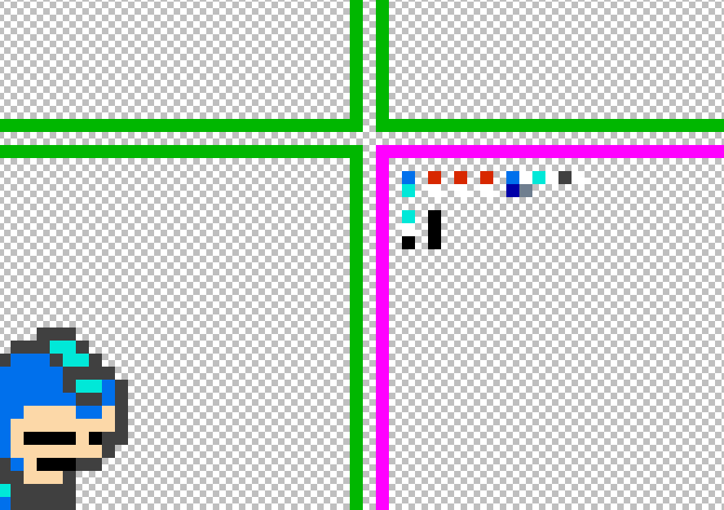

Some of these, you must set to whatever color you wish to utilize, while others are basically “on/off” or options that you set by applying specific colors to those pixels. It looks like a lot, but just like with the rest of the sheet, a lot of it is simple, and a lot of it is optional: This template purposefully excludes some more “advanced ones.” Here is a handy diagram which we’ll go over:

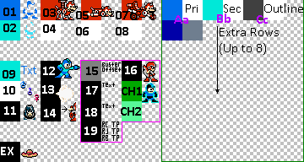

For the most part you can just copy and modify the parameters included in the template, but there are a few extra optional parameters located below the Rush Jet and Rush Bike pixels you might want to add if you’re interested (as well as an EXTRA-optional hat parameter. That’s right). But the important ones are basically 01-14 and the parameters within the green box.

* 01: Primary Color
* 02: Secondary Color
* 03: Rush Coil Primary Color
* 04: Rush Coil Secondary Color
* 05: Rush Jet Primary Color
* 06: Rush Jet Secondary Color
* 07: Rush Bike Primary Color
* 08: Rush Bike Secondary Color

All of these are self-explanatory. Just use the color picker to select the two main colors from your costume that you want to change when you switch weapons. Feel free to get creative and for example only make a badge or a bandanna change colors, but obviously keep in mind any other colors with the same exact values will also be affected.

* 09: **Custom Name Color**. Changes the name of the costume’s name on textboxes to whatever color this pixel is.
* 10: **Pronoun/Species indicator**. Beyond just deciding the costume’s pronouns, it can also set what kind of creature it is, which can affect dialogue all throughout the game. Set R G and B to the below, *exact*, values to make the pronoun/species that specific text. If not specified, it’ll be assumed as a they/them robot.
  + - 0: Robot, she/her
    - 1: Human, she/her
    - 2: Animal, she/her
    - 3: “Entity”, she/her
    - 128: Robot, they/them
    - 129: Human, they/them
    - 130: Animal, they/them
    - 131: “Entity”, they/them
    - 255: Robot, he/him
    - 254: Human, he/him
    - 253: Animal, he/him
    - 252: “Entity”, he/him
* 11: **Enable landing particles**. Set to a 255 white pixel for “on”, any other color is “off:” Creates a puff of slide dust particles when you land. Good for characters that are quite detailed in their animations, or if you want to convey something like weight.
* 12 & 13: **Shot Firing Types**. These pixels basically decide how the costume fires its default Buster—With 12 being normal buster shots, and 13 being charged shots. If it’s pitch black, then it’ll simply shoot them using the default 2nd row (shooting) on the sheet. If it’s any shade of gray, then it’ll use the throwing animation instead.
  + For advanced costume-makers only! If RGB is 255 white, normal firing shots will expect a 4th animation row, right under the tossing animations. This means you can create special attack animations exclusive to either the Buster, the charged shot, or both. For example, you can have a character use a handgun for the buster, then have weapons come out of a bazooka on the 2nd row where the usual default shooting frames go. Getting even craftier—You could have Pixel 20 set to white and Pixel 21 set to black, so shooting normal Buster shots utilizes the 4th row, a handgun, and the charged shot and weapons both use the 2nd row for bazooka blasts!
* 14: **Scarf Animation Mode**. Set to 255 white for “on”, any other color counts as off. Essentially, it makes the costume blink way faster, which allows you to use the blink frames for things such as a flowing scarf (like Proto Man!) or things like a pulsating neon glow… Get creative!
* 15: **Buster Offset value**. If you place down a pixel here whose RGB values are 129/129/129, your costume will fire buster shots one pixel lower than the default height (128 pixels). If it’s 130/130/130, it’ll be *two* pixels lower than the default, and so on for a maximum of **five** pixels. **You cannot make the buster offset any higher or lower than this**. If you need to convey higher shots, it’s recommended you offset the graphic itself, though keep in mind it will not adjust the hitbox.
* 16: **Victory Pose**. Set a 255 white pixel here to turn on, any other color or none counts as “off.” The two yellow boxes where Mega Man turns into Proto Man will be activated and utilized as a victory pose, allowing your costume to pose stylishly after beating a boss. If you want only a single frame, just paste the same one over both boxes.

Let’s move onto explaining the parameters within the green box: “The Auto-Whitemask Parameters.” Veteran costume-makers will know that MaGMML changes weapon colors through a system of “whitemasks”, which basically meant that in previous games, you’d have to make four copies of the same sheet: The “default” sheet; then one where the primary color is 255 white; then one where the secondary color is 255 white; then one with the outline, so the game could know which spots to recolor. It was easy, but tedious and necessary.

Not anymore. 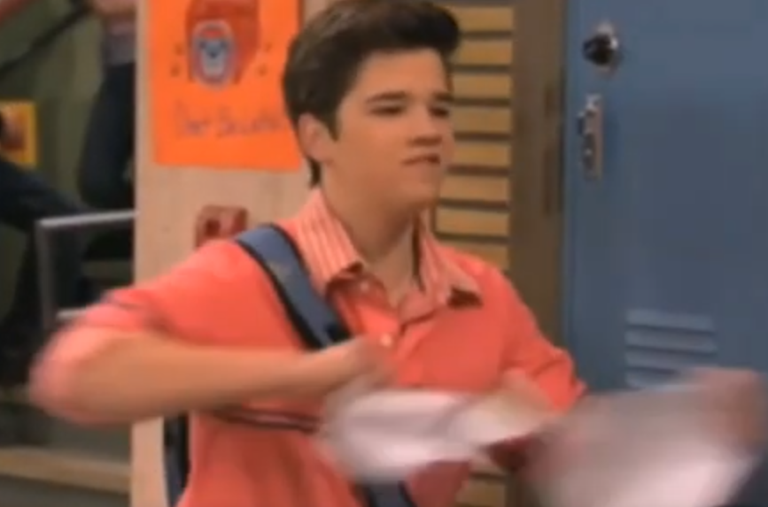

Thanks to the Auto-Whitemask Parameters, which act as basically color replacers, you can just set a pixel of the color you want to be replaced, and then to its right the color you want it to be replaced with (which should generally be 255 white), and the hard work will be done for you.

* Aa: **Auto-Whitemask, Primary Colors**. The uppercase “A” pixel should be whatever your primary color is, and the lowercase “a” pixel should be whatever color you want it to be turned into.
* Bb: **Auto-Whitemask, Secondary Colors**. The uppercase “B” pixel should be whatever your secondary color is, and the lowercase “b” pixel should be whatever color you want it to be turned into.
* Cc: **Auto Whitemask, Outline Color**. The uppercase “C” pixel should be whatever your outline color is, and the lowercase “c” pixel should be whatever color you want it to be turned into.

As implied, if you wish you may make the color of the whitemask be something other than white, but keep in mind that every time you changed weapons, the weapon colors will be *blended* over the color you pick—This means you could use this to make really elaborate hue-shift and shading effects, but **for the most part you’re probably going to want to keep it simple and white**. That said, check the Wily Wars Mega Man costume for a reference and inspiration on how to utilize Autowhitemasks in cool ways!

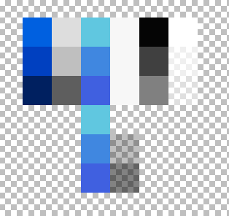

Additionally, though for a standard costume you’re basically only gonna need the first row, you may add *further rows* under each of the Aa, Bb, and Cc pixels to have more elaborate color replacements, which will all result in a more complex and detailed palette for your costume. Once again, Wily Wars Mega Man acts as an example of this, but don’t feel like you have to think about this everytime you make a costume—The fun of custom costumes is that they can be as simple or elaborate as you want them to be!

… By the way, if you’re still attached to the old method, you can still utilize whitemasks the old way; just check the Cirno costume.

Continuing on with the advanced class… The last few Custom Parameters we skipped are even more optional and a little more complicated, but if you’re the type to really get serious about costume-making… Do you want to take your character to the next level? Want a **custom ready text, a custom Mega Buster name, and custom utility names?**

***You can!!***

Let’s use the Cirno sample costume as a guide. Utilize the two yellow boxes with text right under the Sliding frames:

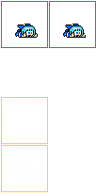

Provided just outside the Costumes folder is an image labeled font_mm2.png**. Copy characters from that font to** write whatever you want the ready text to be in the top two lines of the box, then the name of the Buster in the bottom two lines of the box. Each 8x8 space is converted to its own character, but don’t worry if the words themselves wrap around awkwardly—It’ll be straightened out in-game! Certain fonts when used in Paint.NET may also work, as long as they follow the 8x8 spacing.

Now, let’s return to the custom parameters we skipped:

* + **17: Costume Text Parameters (Part 1)**. Sets the length of various custom costume text blurbs. Each RGB value corresponds to a different setup.
    - R: Length of the READY text.
    - G: Does the ready text use fancy text? Set to 0 black to not use fancy text for READY.
    - B: M. BUSTER text on the pause screen.

Just count the number of characters for the ready text you wrote, and the number of characters for the M. BUSTER text, and then make those the R and B values.

Then, onto the next box, under the READY/BUSTER text one, this one has the utility names for Rush Coil, Rush Jet, and Rush Bike. You get two lines per utility here (the Cirno costume utilizes one-line Rush Coil and Rush Jet and then has “WORLD!” as a buffer line, which doesn’t get picked up because of the custom parameter pixel setting the length). Write out your names, again, with size 6 MegaMan2 font, and then…

* 18: **Costume Text Parameters (Part 2)**.
  + Same as Part 1, except this time it sets the length of the name of the following three utilities on the weapons menu:
    - R. COIL
    - R. JET
    - R. BIKE
* 19: **Rush Teleport Sprites:** R, G, and B correspond to Rush Coil, Jet, and Bike respectively, with a value of 0 in each using the default teleport frames, while 255 uses the player’s teleport frames.
* CH1 & CH2: Does the normal charge palette cycling not work well for your character (e.g. epilepsy risk)? When these two pixels are not fully transparent, your costume will use an alternate charging palette utilizing these two colors. CH1 corresponds to the player’s outline, while CH2 corresponds to the player’s primary color. The player’s secondary will always be white.

And you’re set! It’s a bit of extra work, so save it for really special costumes! And that’s basically—Huh? Oh, right! The hat parameter!

* EX: **Hat clone value**. Throughout MaGMML3’s hubs, you might find a few hats which assume Mega Man’s head for default height. Due to Wily’s nefarious hat traps, you can’t exactly customize where the hat will land on your costume (though if you align it with Mega Man’s hitbox, it should be roughly accurate), but if you’re a veteran costume-maker with experience from MaG48HMML, you can set this pixel to utilize the same color values as 48h’s sunglasses height marker to approximate it closer to whatever your costume’s height may be.

… Okay, that really *IS* all of the Custom Parameters. If you import a costume from a previous game, it’ll create two extra pixels on the far right of the pink box. Feel free to ignore these, as they’re simply markers to keep track of what game they’re from and what version of the importer was used.

Again, though it may be overwhelming, **don’t forget that most of these are optional**, and it’s basically no different from a settings menu, just built into the picture itself through Sophisticated Technology (trademarked). For the most part, you can stick to the basics present in the template, and save getting fancy for costumes you want to put a lot of love into.

… Do you still want more?

CUSTOM SOUNDS

You can add custom sounds to your character in MaGMML3! To create custom sounds, first edit the sound in your favorite sound editor. Then, name the file the same as your character PNG like so: [MyCoolCharacter].[soundEffectTag].ogg

The following supported tags are below. Sounds with an * should not have that in the file name, but it indicates that said sound is not something played in the game with the normal set of costumes.

* buster
  + All buster sound effects are overridden when a Humor Buster is equipped.
* busterCharged
* busterHalfCharged
* busterCharging
  + (Does not loop: It is recommended you fade this sound out after a couple loops).
* bossDoor
* hurt
* land
* jump*
* slide*
* life
* tank
* death
* refill
  + (blips made when healing health)
* splash
* teleportIn
  + (v1.1) Also applies to Rush Supports if custom teleport sprites are used.
* teleportOut
  + (v1.1) Also applies to Rush Supports if custom teleport sprites are used.
* pause
* unpause
* victory
  + Replaces the normal victory theme obtained when acquiring an energy element.
    - Does not replace other victory jingles, such as tier boss victory.
* bikeStart (v1.03)
* bikeJump (v1.03)
* bikeSkid (v1.03)
* pose (v1.03)
  + Plays with the optional pose sprite.
* lookUp (v1.05)
  + Plays when using Morale Booster. Does not play when using a vehicle.
* spin (v1.05)
  + Plays when using Balance Stabilizer. Does not play when using a vehicle.
* whistle (v1.1)
  + Plays when entering a stage, around the same time Proto Man’s whistle plays when using his skin.

OTHER NOTES

* For the Ink effect used by Octone, 255 white is used to determine whether the eyes should be shown.
* Unlike previous games, the mugshot is rendered with weapon colors in most cases.
* It’s recommended to store costumes within their own folders, but only the PNG and associated sound files matter for the character’s name. You can name the folder whatever works best for you!

-----------------------------------------------------------------------------------------------

… Whew! That’s all! With so many options and so many possibilities, being a costume-maker can seem overwhelming, but don’t feel like you have to think about every single possibility with every costume you make. Keep it simple if you’re starting off and then escalate as you make more! Feel free to use sprites from existing games, and make whatever your heart desires. And if things get rough, there’s a strong community of other costume-makers willing to provide support and tips in the Discord.

Be yourself the most you can be, costume wearers!   
Embody that dream!

-Crafts Man

(P.S. If Maker Man asks; tell him I’d love to get some food with him again as soon as I’m back from my trip. An artist must be always learning, and my school is life! I’ve got a lot of stories to tell about Iran already!)